

**Well - Health & Personal Care**

**Web Application Development**

**Date: 31 July, 2024**

**Created For: Steve George**

**Created By: Team MYDASA**

1. **Project Overview**

**WELL - Health & Personal Care** is an e-commerce website that providesa wide range of health and personal care products. Our offerings include health supplements, personal care products, and organic supplements. The primary goal is to create a user-friendly, secure, and visually appealing platform where customers can easily find and purchase products that enhance their health and beauty.



1. **Target Audience**

Our target audience includes male and female customers aged between 18 and 55 years. They are health-conscious individuals who prioritize wellness and beauty. This demographic is tech-savvy, values convenience, and seeks high-quality products. Our target audience includes both male and female customers aged between 18 and 55 years. They are health-conscious individuals who prioritize wellness and personal care. This demographic is tech-savvy, values convenience, and seeks high-quality products. Our target audience includes both **male and female customers aged between 18 and 55 years**. They are health-conscious individuals who prioritize wellness and beauty. This demographic is tech-savvy, values convenience, and seeks high-quality products.



1. **Project Details**

**Project Name: Well - Health & Personal Care**

**Project Duration: 2 Weeks**

**Scope of Work:  User / Guest (Frontend)**



1. Product Listing
2. User Accounts
3. Shopping Cart
4. Checkout
5. Order Tracking
6. Customer Reviews
7. Search Products
8. Newsletter Signup

**Admin Dashboard**



1. **Product Management**

* Create
  + Add new product
* Read
  + View list of all products
  + View product details
* Update
  + Edit existing product
* Delete
  + Remove product.

2. **Category Management**

* Create
  + Add new category
* Read
  + View list of all categories
* Update
  + Edit existing category
* Delete
  + Remove category

3**. User Management**

* Create
  + Add new user
* Read
  + View list of all users
  + View user details
* Update
  + Edit existing user
* Delete
  + Remove user

4**. Order Management**

* Create
  + (Typically, orders are created by users; however, the admin can manually create orders for customers if needed)
* Read
  + View list of all orders
  + View order details
* Update
  + Edit existing order
* Delete
  + Remove order

**Deliverables:**

1. Functional Web Application for all listed features
2. High-fidelity design mock-ups
3. UI/UX design specifications
4. Database schema and setup scripts
5. Frontend and backend code
6. Integration with payment gateway
7. Security requirements document and penetration testing report
8. Post-launch maintenance and support plan

**4. Technologies**

**Frontend:**



HTML, JavaScript, Bootstrap, SCSS, jQuery, nodejs, npm, vite

**Backend:**



PHP, Laravel, Composer

**Database:**



MySQL

**Server**



ubuntu/apache2, certbot

**Payment Gateway**



Stripe/Authorize.net (PCI DSS Compliance Gateway)

**5. Proposed Design Solution**

**Design Principles:**

* **User-centric**: Easy navigation, intuitive layout, and responsive design.
* **Aesthetic Appeal**: Modern and clean design focusing on health and wellness.
* **Accessibility:** Ensuring the website is accessible to all users, including those with disabilities.

1. **Home Page:**

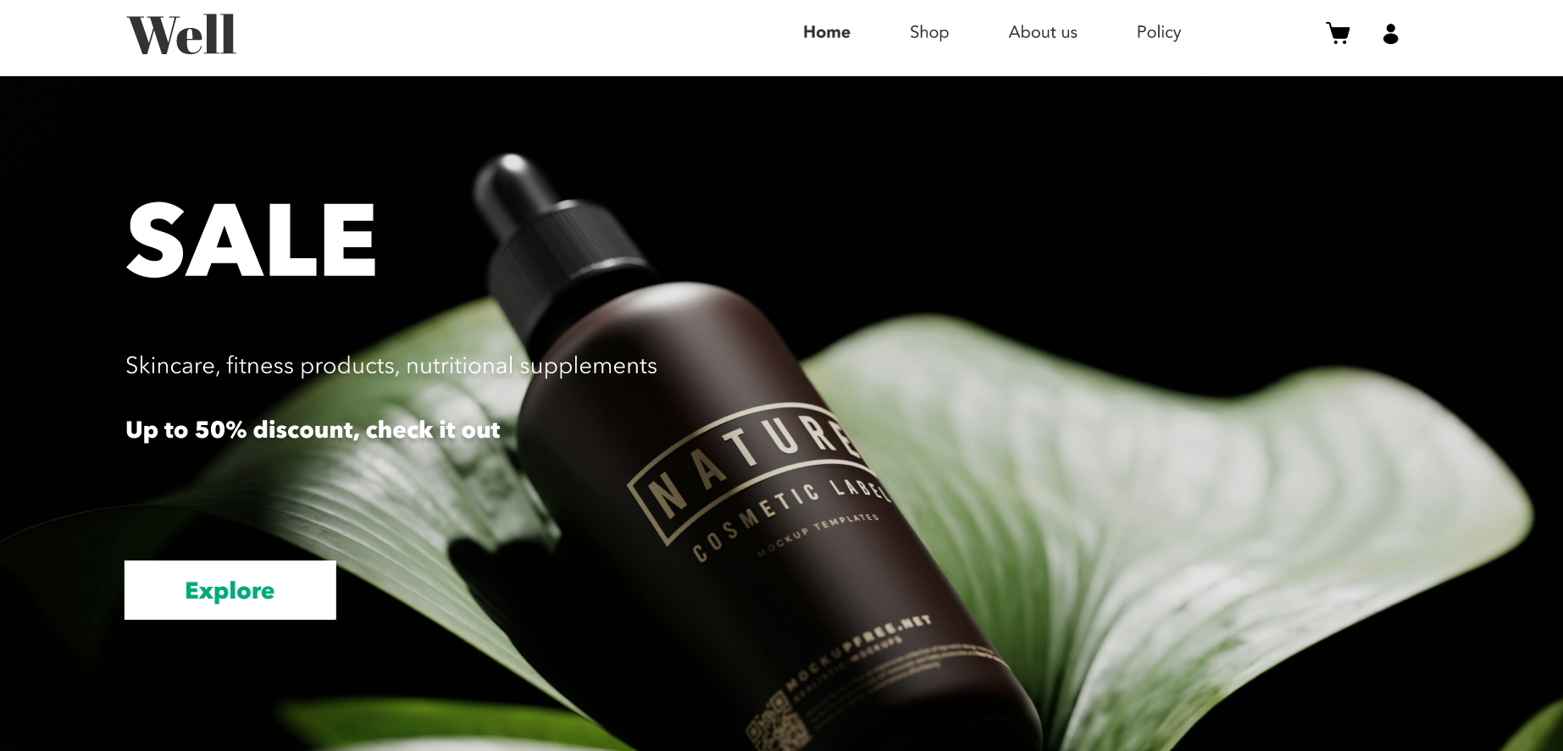

**Categories on the Landing Page**

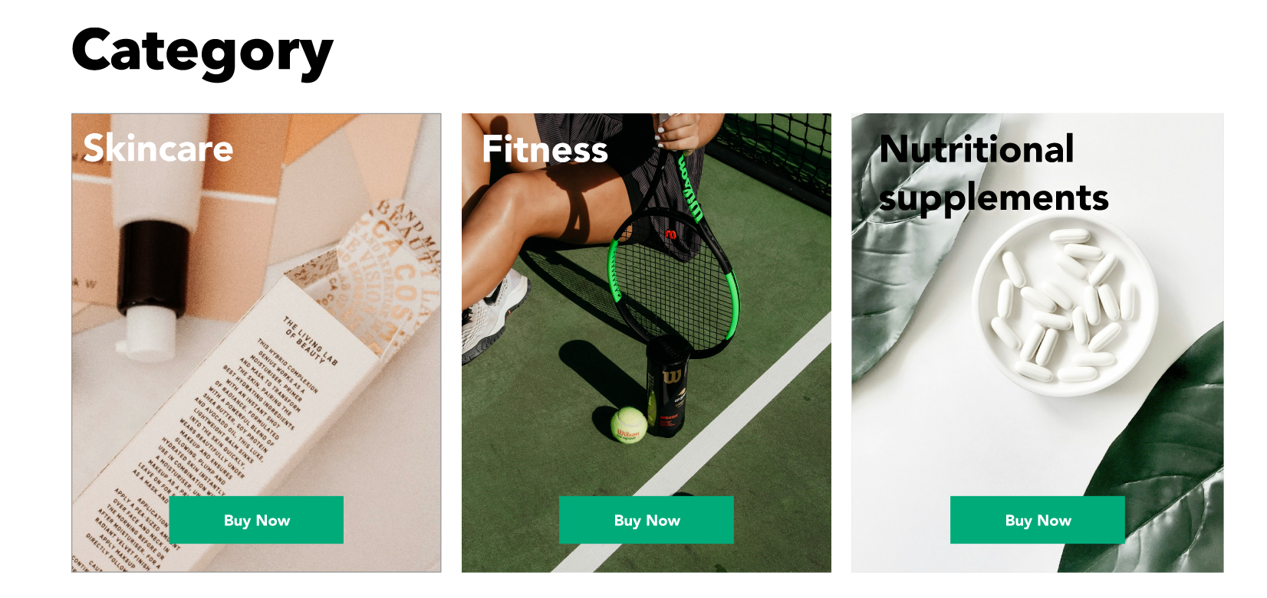

**Best Selling Products**

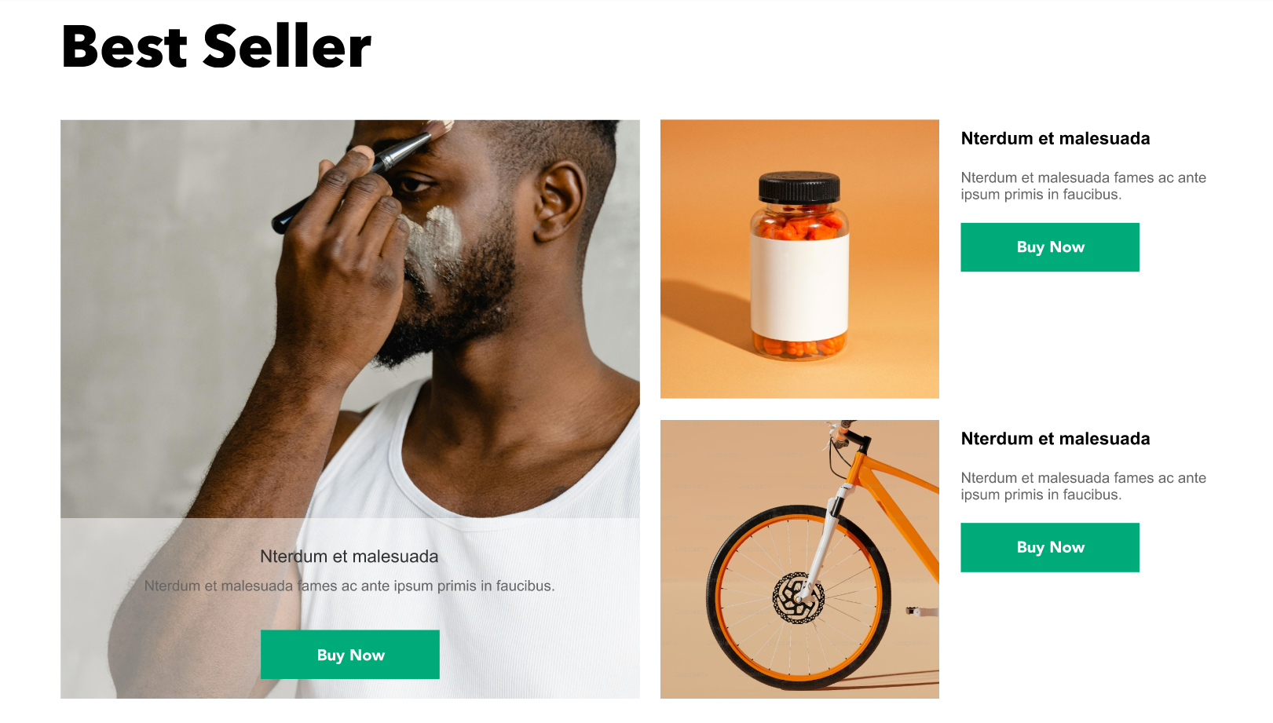

**Footer**

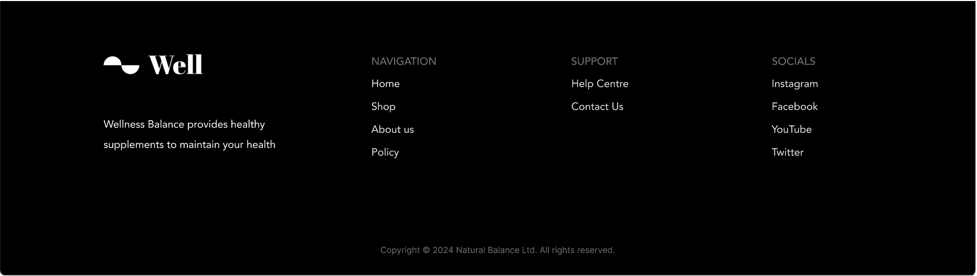

1. **Product Page:**

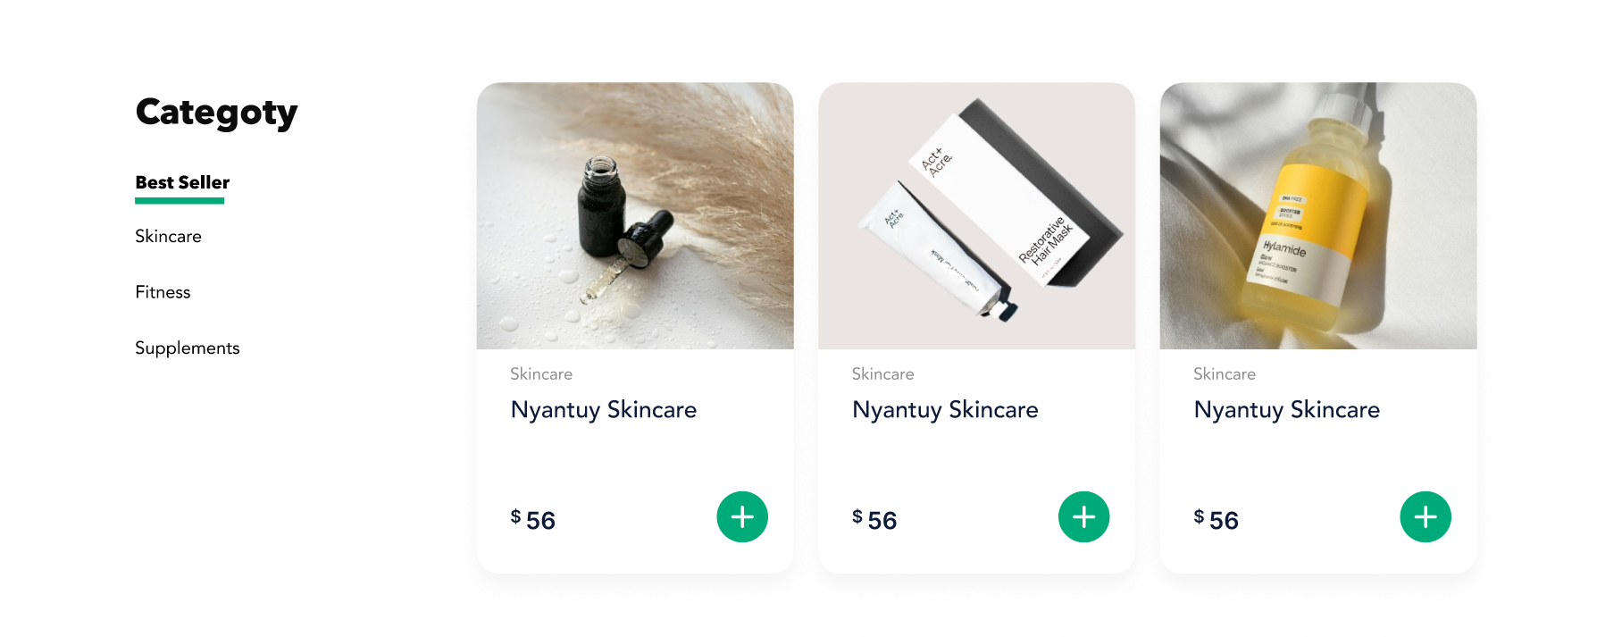

**6. User Personas/Use Case Statements**

**1. Jane Doe (28, Female)**



**Guest User**

**Description:**

* **Demographics:**Unauthenticated users, potentially new visitors.
* **Needs:** Explore products, read reviews, and learn about the website's offerings.
* **Behaviour:** Browses products without making purchases, might consider signing up for an account.

**Use Case Statement:**

* As a Guest, Jane wants to browse a variety of health and beauty products so that she can decide whether to sign up and make a purchase.

1. **John Smith (35, Male)**



**Authenticated User**

**Description:**

* **Demographics:**Registered users, both male and female, aged 18-55.
* **Needs:**Access personalized recommendations, track orders, and manage their account.
* **Behaviour:**Regularly logs in to purchase products, leaves reviews, and participates in the loyalty program.

**Use Case Statement:**

* As an Authenticated User, John wants to view his order history so that he can track his past purchases and reorder products easily.

**3. Erik Wilson**



**Customer Service Representative (CSR)**

**Description:**

* **Demographics:**Employees of the company responsible for handling customer inquiries.
* **Needs:**Access to user accounts and order details to provide support.
* **Behaviour:**Logs in to assist customers with their queries, resolves issues related to orders, and processes returns.

**Use Case Statement:**

* As a CSR, Erik wants to access customer order details so that he can assist customers with any issues they may have.

**4.Joe Root**



**Admin**

**Description:**

* **Demographics:**Site administrators are responsible for managing the website.
* **Needs:**Full access to all site functionalities to manage products, users, and orders.
* **Behaviour:**Regularly updates product listings, manages user accounts, and monitors sales and website performance.

**Use Case Statement:**

* As an Admin, Joe wants to add new products to the catalogue so that he can keep the website's offerings up to date.

**7. Sitemap (Front End)**

**7.1 Sitemap (Back End)**

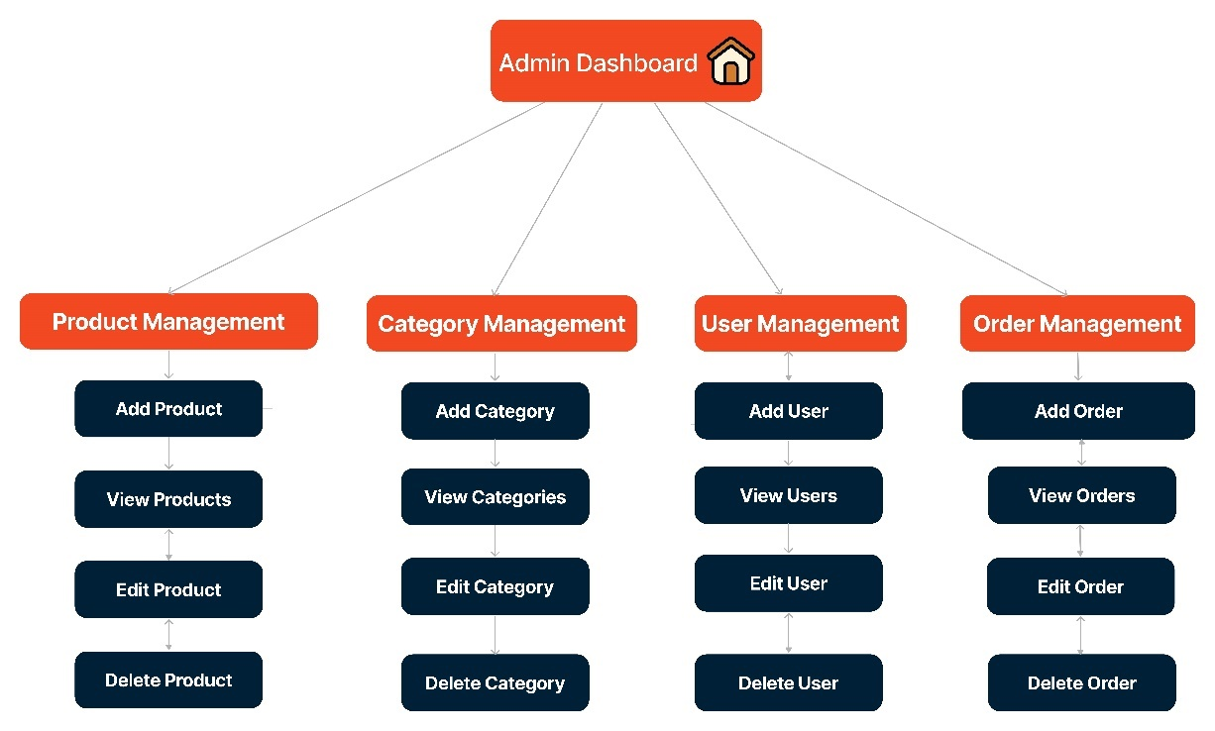

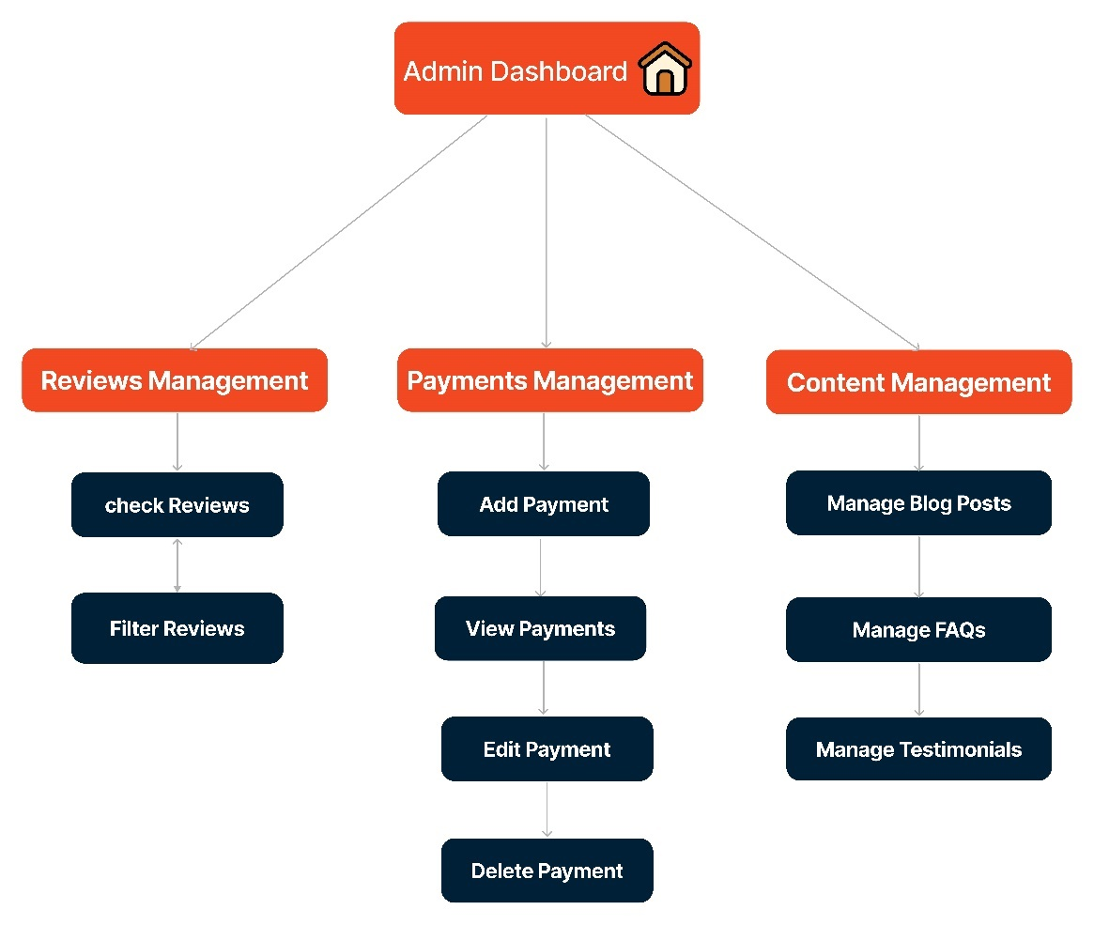

**8. Server**



**Ubuntu Server**

**Overview**

* **Operating System:** Ubuntu (a popular Linux distribution known for its stability and user-friendliness)
* **Use Case:** Ideal for web servers, development environments, and other server applications

**Apache2**

**Overview**

* **Web Server:** Apache2 is a widely used open-source web server that provides a robust, flexible, and secure platform for hosting websites.

**Certbot**

**Overview**

* **SSL Certificate Tool:** Certbot is an open-source tool for automatically using Let's Encrypt certificates on manually administrated websites to enable HTTPS.

**9. Security on the Server**



**Load Balancers**

* **Function:** Distributes incoming network traffic across multiple servers to ensure no single server becomes overwhelmed.
* **Benefit:** Improves availability and reliability of application by balancing the load. Very useful in protecting server from **DDoS Attacks.**

**Firewall**

* **Function:** Monitors and controls incoming and outgoing network traffic based on predetermined security rules.
* **Benefit:** Protects the server from unauthorized access and potential threats by filtering traffic.

**Data Encryption**

* **Function:** Encrypts data both at rest and in transit using algorithms like AES-256.
* **Benefit:** Ensures that sensitive data is protected from unauthorized access and breaches.

**Continuous Security Practices**

* **Regular Updates:** Keeping the operating system and all software up to date to protect against vulnerabilities.
* **Access Control:** Use of SSH keys for authentication and disable password-based logins.
* **Monitoring and Logging:** Implement continuous monitoring and logging to detect and respond to security incidents promptly.
* **Backup and Recovery:** Regularly back up data and have a recovery plan in place in case of data loss or corruption.

**9.1 Security in the Web Application**



**Input Validation**

* **Function:** Ensures that only properly formatted data is entered into the system.
* **Benefit:** Prevents common vulnerabilities like SQL injection and XSS by validating user input.

**Output Sanitization**

* **Function:** Cleans and encodes output data before sending it to the user's browser.
* **Benefit:** Protects against XSS attacks by ensuring malicious scripts are not executed in the browser.

**Role-Based Access Control (RBAC)**

* **Function:** Restricts access to resources based on the user's role within the application.
* **Benefit:** Ensures that users can only access the functionalities and data that are necessary for their role.

**CSRF Tokens**

* **Function:** Uses unique tokens for each session to prevent Cross-Site Request Forgery attacks.
* **Benefit:** Ensures that unauthorized commands are not executed on behalf of authenticated users.

**Session Management**

* **Function:** Manages user sessions securely with mechanisms like session expiration and regeneration.
* **Benefit:** Prevents session hijacking and fixation by properly managing user sessions.

**SSL (Secure Sockets Layer)**

* **Function:** Encrypts data transmitted between the client and the server.
* **Benefit:** Protects data in transit from being intercepted or tampered with by attackers.

**Defensive Coding Practices**

* **Authentication:** Implementation of strong authentication mechanisms, such as multi-factor authentication (MFA).
* **Error Handling:** Preventing exposing detailed error messages to users, as they can provide valuable information to attackers.
* **Security Headers:** Using HTTP security headers like Content Security Policy (CSP), X-Content-Type-Options, and X-Frame-Options to protect against various attacks.
* **Regular Security Audits:** Conduct regular security audits and vulnerability assessments to identify and address potential security issues.

**10. Database**

**Entities and Relationships**

1. **Users**
   * **Attributes:** ID, Username, Password, Email, FullName, Address, PhoneNumber, Is_Admin, Created_At, Updated_At
   * **Purpose:** Manages user information, including both customers and administrators.
2. **Products**
   * **Attributes:** ID, ProductName, Description, Price, Stock, ImageURL, Color, Rating, Discount, Created_At, Updated_At
   * **Purpose:** Stores detailed information about the products available for sale.
3. **Categories**
   * **Attributes:** ID, CategoryName, Description
   * **Purpose:** Organize products into various categories for easy navigation.
4. **Orders**
   * **Attributes:** ID, UserID, OrderDate, TotalAmount, ShippingAddress, Status, Quantity, Price
   * **Purpose:** Tracks order details and status for each purchase.
5. **Payments**
   * **Attributes:** ID, OrderID, PaymentMethod, PaymentDate, Amount, Tax, GST, Discount, PaymentStatus, TransactionID
   * **Purpose:** Records payment details for orders.
6. **Transactions**
   * **Attributes:** ID, OrderID, Transaction_ID, TransactionStatus, TransactionResponse, SofDelete, Timestamp
   * **Purpose:** Tracks transaction details associated with payments.
7. **Reviews**
   * **Attributes:** ID, ProductID, UserID, Rating, ReviewText, ReviewDate
   * **Purpose:** Stores customer reviews and ratings for products.
8. **ShoppingCart**
   * **Attributes:** ID, UserID, CreatedDate
   * **Purpose:** Temporarily holds items that users intend to purchase.
9. **CartItems**
   * **Attributes:** ID, CartID, ProductID, Quantity
   * **Purpose:** Manages individual items within a shopping cart.
10. **Wishlist**
    * **Attributes:** ID, UserID, CreatedDate
    * **Purpose:** Allows users to save products for future reference.
11. **WishlistItems**
    * **Attributes:** ID, WishlistID, ProductID
    * **Purpose:** Manages individual items within a wishlist.

**Key Relationships**

* **Users to Orders:** A user can place multiple orders.
* **Orders to Payments:** Each order can have multiple payment records.
* **Orders to Transactions:** Each order can have multiple transactions.
* **Products to Reviews:** Each product can have multiple reviews.
* **Products to Categories:** Each product can belong to one category, but a category can have multiple products.
* **ShoppingCart to CartItems:** Each shopping cart can have multiple items.
* **Wishlist to WishlistItems:** Each wishlist can have multiple items.

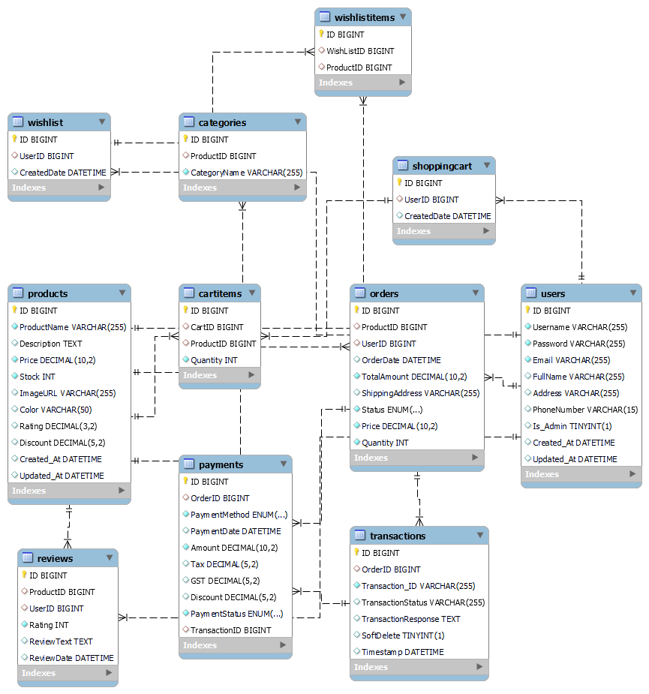

**11. Value adds**

**BRANDS and VENDORS**

To enhance the "WELL" Health & Beauty e-commerce platform, we have added two key features:

**BRANDS Table**

* **Attributes:** ID, BrandName, Description, ProductID
* **Benefit:** Allows products to be categorized by brand, enabling brand-specific promotions and improved customer experience.

**VENDORS Table**

* **Attributes:** ID, VendorName, ContactPerson, ContactEmail, ContactPhone, ProductID
* **Benefit:** Supports multiple vendors, facilitating marketplace expansion with diverse product offerings and competitive pricing.

**Marketplace Expansion**

These features prepare "WELL" for future growth in a marketplace. By supporting multiple brands and vendors, the platform can offer a wider variety of products, attract more customers, and create new revenue streams through vendor partnerships. This strategic addition positions "WELL" for scalability and long-term success in the competitive e-commerce landscape.

**12. Revised ERD for Value Adds**

**Changes to the ERD:**

1. **Addition of BRANDS Table:** Each product can be associated with one brand, and a brand can have multiple products. This introduces a one-to-many relationship between the BRANDS table and the PRODUCTS table.
2. **Addition of VENDORS Table:** Each product can be associated with one vendor, and a vendor can supply multiple products. This creates a one-to-many relationship between the VENDORS table and the PRODUCTS table.

These changes will enable the **"WELL"** platform to support brand categorization and vendor management, enhancing the system's capability to expand into a marketplace. The revised ERD will incorporate these additional tables and relationships to facilitate the new value-added features.

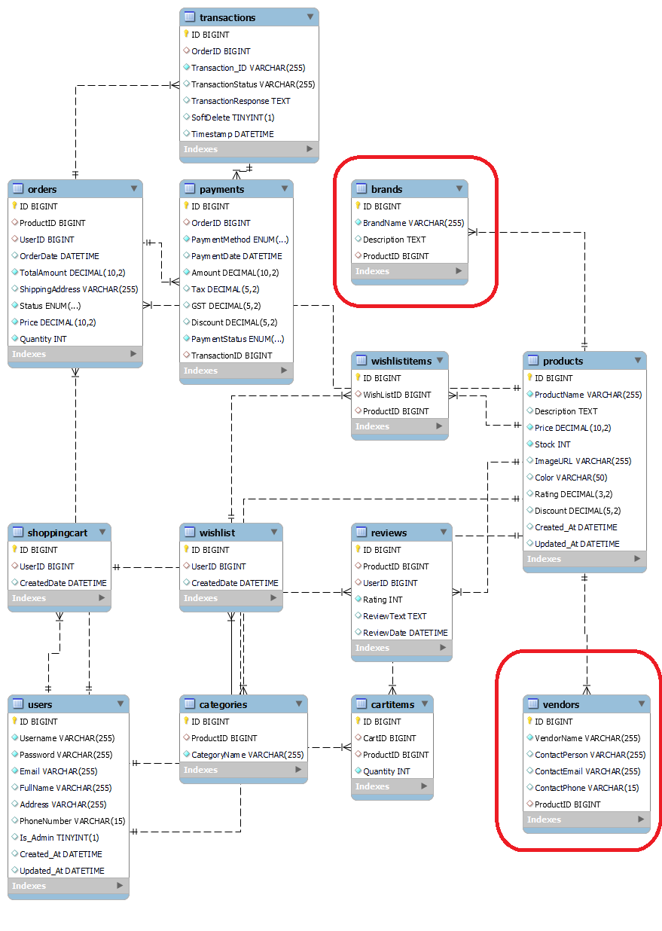

**13. Our Team**

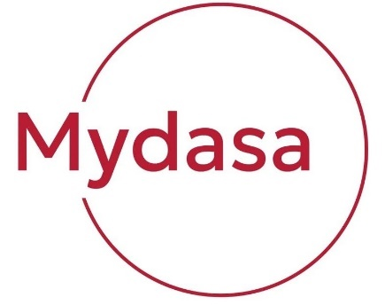



**Manish Kumar:** Project Manager



**Yongdong Xiang:** Lead Backend Developer, Git Manager



**Dongqing Ye:** Lead UI/UX Designer, Front End Developer



**Aman Dawar:** Front End Developer, Database Engineer



**Shivangi Koradiya:** Lead Database Engineer, Backend Developer